11.1.2 Editors - Compositor Editor - Header - View Menu
View Menu 2
Toolbar 2
Sidebar 2
Zoom In 2
Zoom Out 2
Zoom Border 2
View Selected 2
View All 2
Area 3
Horizontal Split 3
Vertical Split 3
Duplicate Area into New Window 3
Toggle Maximize Area 3
Toggle Full screen Area 3
View Menu with Backdrop 3
Backdrop Move 3
Backdrop Zoom In 3
Backdrop Zoom Out 4
Fit Backdrop 4
Set Viewer Region 4
Clear Viewer Region 4

View Menu

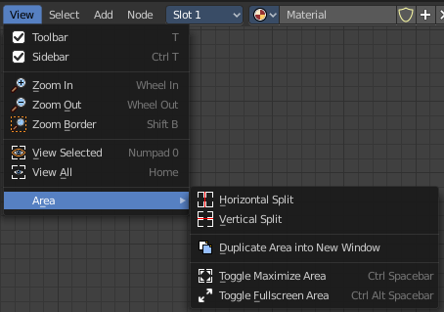
The View menu contains all View related tools.

The content is the same in all sub modes.

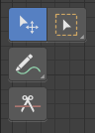
Toolbar
Shows or hides the toolbar at the left.

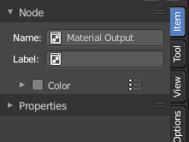
Sidebar
Shows or hides the sidebar at the right in the viewport.

Zoom In
Zooms into the viewport.

Zoom Out
Zooms out of the viewport.

Zoom Border
Draws a rectangle and zooms then to fit the size of this rectangle.
Zooming in is done with drawing the rectangle with left mouse button. Zooming out is done with drawing the rectangle with middle mouse button.

View Selected
Zooms to the selection.

View All
View all zooms in or out in the viewport until all objects in the scene are displayed fitting in the viewport.


Area
This menu contains general view functionality. And exists in most other editor types too.

Horizontal Split
Splits the current view horizontally into two independant editor windows.

Vertical Split
Splits the current view vertically into two independant editor windows.


Duplicate Area into New Window
Duplicate Area into New Window makes the selected editor window floating. You can then drag it around at the monitor. It is not connected with the rest of the UI anymore.
A separated window cannot be merged into the main window again. You have to close it when not longer needed.

Toggle Maximize Area
Displays the editor maximized with menus.
To return from the maximized view press hotkey ctrl + spacebar. Or reuse the menu item in the area menu.

Toggle Full screen Area
Displays the editor maximized without menus.
To return from the full screen view press hotkey ctrl + alt + spacebar.

View Menu with Backdrop

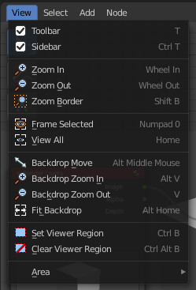
When you activate the Backdrop in the header, then the View menu reveals some more functionality.

Backdrop Move
Move the backdrop image

Backdrop Zoom In
Zoom into the backdrop image.

Backdrop Zoom Out
Zoom out of the backdrop image.

Fit Backdrop
Fit the backdrop to the viewport.

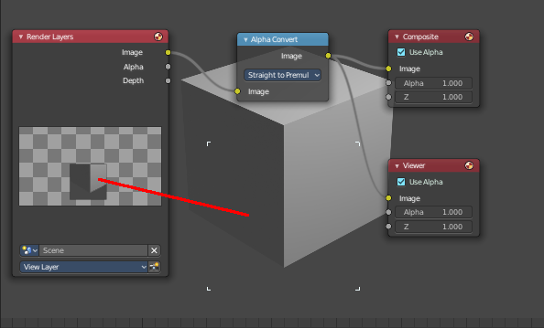
Set Viewer Region
Allows you to define a area of the Backdrop. Then just this are gets processed.

Clear Viewer Region
Removes the Viewer Region.

